Kanban Board How-To Guide
Step 1 – Choose your Kanban board platform
- Find the best platform for your team
  - Microsoft Planner
  - Trello
  - Monday.com
- Considerations
  - Cost
    - You may already have a license to use MS Planner
    - Trello and Monday.com have free versions
  - Inter-Organization Access
  - Notifications
Step 2 – Set up your Kanban board for the project
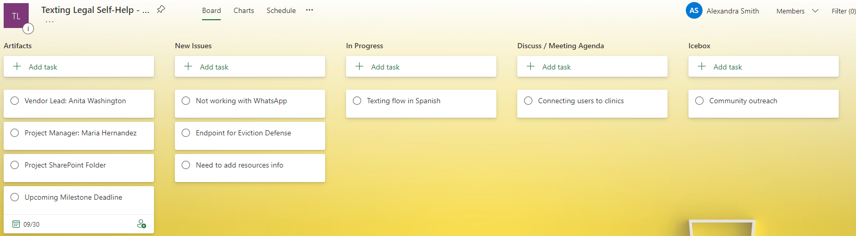

- Common buckets
  - Artifacts
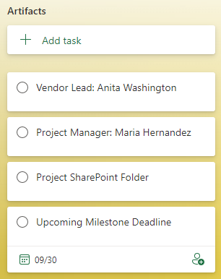
  - New Issues
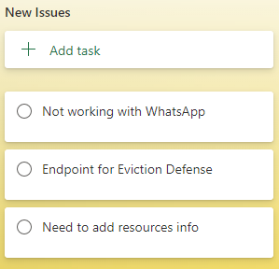
  - In Progress
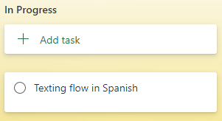
  - Discuss / Meeting Agenda
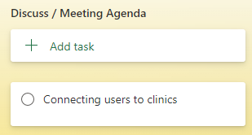
  - Icebox
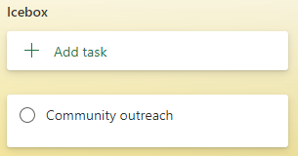
Step 3 – Add team members
- Add your team members to the Kanban board
- Assign tasks to team members as appropriate
Step 4 – Track each task
- Open each task and add detail
- Upload documentation to each task as necessary
- Update the notes section in each task throughout the lifecycle
- Utilize the drag and drop feature to move the task when its status changes

